**Crop Guider**

**Project Code**

10

**Project Advisor**

**Project Manager**

**Project Team**

Muhammad Younas BCSF18M025 Team Lead

Hammad Ullah BCSF18M029 Team Member

**Submission Date**

08/11/2021

**Table of Contents**

1. Abstract **………………………………………………………………………………….………**3
2. Background and justification**…………………………………………………………………...**3
3. Project methodology**…………………………………………………………………………….**3
4. Project scope**…………………………………………………………………………………….**4
5. High-level project plan**………………………………………………………………………….**4
6. References**……………………………………………………………………………………….**5

# Abstract

Usage of traditional methods and lack of guidance to farmers is the problem leading to less production or less suitable crop. For guidance, the farmer has to waste time and effort. Taking these circumstances into account, we are going to design a website, the goal of which is to facilitate those farmers. The website will contain all the necessary information about some selected crops which can be grown in district Sargodha.

The first step we are going to do is to collect all the necessary information about those crops from experienced farmers, agricultural scientists, and research journals. And then we will start working on our website development. The academic benefit of this project is that after completion of this project we will be able to make a professional website and we will learn teamwork. It will also help us to pass the Capstone project. The industrial benefit of it will be an increase in the production of crops and it will help the farmer and agriculture-related industries monetarily.

# Background and Justification

Pakistan is considered as an agricultural country and agriculture is the backbone of the country’s economy. According to a survey of the Pakistan Bureau of Statistics, 39% of the country’s labor force is engaged in agriculture and agriculture contributes 18.5% of the GDP (Gross Domestic Product) of the country. But most farmers don’t know exactly which type of soil is good for a particular crop, the exact quantity of seed, amount and timing of fertilizers, proper time of watering, and required pesticides. As people prefer to grow crops that are traditionally common in their area and are afraid to grow other crops which can give them relatively more benefits. The reason behind this hesitation is the lack of proper guidance and the lack of technology usage.

The world has increased its agricultural growth by using the latest technology and we are wandering around typical old fashion techniques. Proper guidance and advice to farmers can encourage them to grow new kinds of crops that are relatively more suitable for those particular areas. More production will lead to more financial benefits.

Internationally, there are many digital platforms i.e., android applications and websites, which provide farmers proper instructions about sowing, fertilizing, watering, harvesting, and storing. They even notify you at the exact moment i.e., when to water or when to use pesticides. In Pakistan, there are some applications and websites like kisandost.com [1] and aari.punjab.gov.pk [2]. These websites are covering a large number of crops and the scope of their area is the whole of Pakistan. We are also going to develop a website in which we are going to select some crops of Sargodha district and provide all the necessary information about these crops. We will make the interface as simple as possible so that a layman can navigate through our website and skim out desired information. We will use Urdu and English language in it so that the user can read in his preferred language. We will also make it responsive for every device IA.

# Project Methodology

The first step we are going to do is to collect all the necessary information about those crops from experienced farmers, agricultural scientists, and research journals. After that, we will countercheck the gathered information. After making it reliable and accurate we will move to the creation of the template. Then we will move towards the backend development and launch the website afterward. The main intended functions of the project are listed below.

* **View crop choices:**

We will add 6 crops of district Sargodha, out of which users can view the crop of his/her choice.

* **Select desired crops:**

The user can select the desired option out of the available six and get the information about them. Users will also be given the necessary information about different types or variations of one crop.

* **Select best quality seeds:**

The user can get information about the selection of the best suitable seeds for his area or of his choice.

* **Viewing watering information:**

The user can get the watering information such that when the crop should be watered and the amount of water required

* **Suggesting best fertilizers and pesticides:**

The user will be able to get all the information related to fertilizers such as the amount and kind of fertilizers. The user will also be suggested ways to eradicate all the pests which can be harmful to crops

* **Viewing fertilizing time:**

Users will be informed about the best suitable time for fertilizing with a particular fertilizer.

* **Predicting rain in the area:**

We will also add a function that will predict rain in different areas of Sargodha so that farmers can water the crops accordingly.

* **Suggesting best time for harvesting crop:**

The farmers will be told about when and how to harvest the crop.

* **Suggesting best ways to store the crops:**

Farmers will be suggested the best ways to store the crop if they want to store it for later usage.

# Project Scope

We will be covering all the related aspects of 6 crops i.e. maze, rice, wheat, sugar cane, mustard, and cotton. The project’s focus area is district Sargodha. It will be a web-based project. It doesn’t include all the crops. The area under the focus of our project is district Sargodha.

# High-level Project Plan

|  |  |  |
| --- | --- | --- |
| **S.no** | **Task name** | **Time allocated** |
| 1 | Requirement gathering | 2 weeks |
| 2 | Problem analysis and proposal | 2 weeks |
| 3 | Documentation | 4 weeks |
| 4 | Design | 3 weeks |
| 5 | Coding | 4 weeks |
| 6 | Development | 2 weeks |
| 7 | Implementation | 3 weeks |
| 8 | Testing | 2 weeks |

# References

* [www.kisandost.com](http://www.kisandost.com)
* [www.aari.punjab.gov.pk](http://www.aari.punjab.gov.pk)
* [www.syngenta.com.pk](http://www.syngenta.com.pk)
* [www.agripunjab.gov.pk](http://www.agripunjab.gov.pk)

**Software Requirements Specifications**

**Crop Guider**

Internal Advisor:

External Advisor:

Project Manager:

Mr. Saad Razzaq

Project Team:

Muhammad Younas BCSF18M025 Team lead

Hammad Ullah BCSF18M029

Submission Date:

23/11/2021

### _____________________

**Project Manager’s Signature**

**Table of Contents**

_____________________ 1

1. Introduction 3

1.1 Purpose of Document 3

1.2 Project Overview 3

1.3 Scope 3

2. Overall System Description 3

2.1 User characteristics 3

2.2 Operating environment 3

2.3 System constraints 3

3.1 Hardware Interfaces 3

3.2 Software Interfaces 3

4. Functional Requirements 4

5. Non-functional Requirements 4

5.1 Performance Requirements 4

5.2 Safety Requirements 4

5.3 Security Requirements 4

5.4 User Documentation 4

6. References 4

1. **Introduction**
   1. **Purpose of Document**

*The purpose of this document is to keep a record of all the necessary steps that are taken to build a crop guider system. The document will comprise all the necessary information about the development of the website i.e., the methodology of project development, basic functions of the project, and the reason behind all the choices made during the process of project completion. The intended audience of the project is the farmers of district Sargodha. Most farmers are not fluent in English so we will provide an Urdu version of the website as well.*

* 1. **Project Overview**

*Crop guider project is a web-based project which will enable its users to get an idea about the investment and return of investment of six crops in district Sargodha. It will give a complete pathway to its users about the complete lifecycle of a crop and its storage. The website will be very easy to use because of its simple UI. The goal of the above-mentioned project is to give awareness to farmers of Sargodha about six different crops and persuade them to grow the crops that will benefit them monetarily. The website will benefit its users as they will be able to think about different options for the cultivation of different crops. Users will be able to select the best option to get more production and profit.*

* 1. **Scope**

*The website of Crop Guider will cover all the necessary information about crops of maize, rice, wheat, sugar, cane mustard, and cotton. Other crops are beyond the scope of the project. The District of Sargodha is the area under the scope of the project. There are seven tehsils in Sargodha that will be under discussion accordingly.*

1. **Overall System Description**
   1. **User characteristics**

*There will be two types of users. The first one is administrators who can change the Crop Guider system and can add or remove any module they want and can add any updated information. Then there are system users which will be farmers and can view the system and can access all the information about the crops and can calculate the expected investment and returns on investments.*

* 1. **Operating environment**

*Crop Guider system will be a web-based system that will be developed in Sublime text and using Xampp in Windows 10. It will be a responsive website that can be opened on any type of device. Languages used to develop it will be PHP, MySQL, HTML, CSS, JavaScript, etc.*

* 1. **System constraints**
* *There is no constraint on software or hardware because it is a web-based responsive project so it can be opened on any device with an active internet connection.*
* *It will include Urdu and English languages both because of less knowledge of intended users in the English language*
* *The system is developed for farmers so that they can get the intended benefits.*

1. **External Interface Requirements**
   1. **Hardware Interfaces**

*There are no hardware interfaces.*

* 1. **Software Interfaces**

*The homepage of the website will contain tabs with different options for crops. Users can select any of the six crops i.e., maize, rice, wheat, sugar, cane mustard, and cotton. Then there will be an information page about every single crop which will contain information about types of above-mentioned crops, best quality seeds, watering, fertilizers, and pesticides. It will also predict harvesting time, rain and investments, and storage information.*

1. **Functional Requirements**

***Register()***

*The user will create his account on the website to get desired information.*

***Login()***

*The registered users will have to log in before seeing the information about a website.*

***AddCrop()***

*The administrator can add a crop and give all the related information about that particular crop.*

***DeleteCrop()***

*The administrator can delete any crop that already exists in the system. This will delete all the related information about that crop.*

***EditCrop()***

*The admin can edit any information about a crop that already exists on the website.*

***AddCropInfo()***

*The admin will be able to add any new information about a crop.*

***PredictRain()***

*The system will predict the rainfall in the area so that farmers can sow and water their crops accordingly.*

***PredictInv()***

*The system will predict the average investment in crops in Sargodha.*

***PredictROI()***

*The system will predict the return on investment so that farmers can choose crops that benefit them more.*

1. **Non-functional Requirements**
   1. **Performance Requirements**

*The website will be responsive so that it can be viewed on every device. It will also be user-friendly i.e., it has a simple user interface so that users can find the desired information easily. It will also contain Urdu and English language so that the user can view the information in their preferred language. The site will contain validated and verified information.*

* 1. **Safety Requirements**

*The system will predict the rain, investment, and return on investment. These will be mere predictions that will be resulted from limited resources so, the farmers should not only rely on these predictions. We will try to ensure the accuracy of our predictions by using all the appropriate methods that will affect predictions.*

* 1. **Security Requirements**

*Only the administrator will be able to edit any information on the website. The other users can only signup, log in, and collect intended information, so there is no data leakage and the admin will be responsible for any security issue caused by the system.*

* 1. **User Documentation**

*The user manual will be given along with the system which will give details about the modules of the system, guide the users about the navigation of the system, and brief them on how to get the information they need.*

1. **References**

|  |  |  |  |
| --- | --- | --- | --- |
| **Ref. No.** | **Document Title** | **Date of Release/ Publication** | **Document Source** |
| 1 | Crop Guider.docx | 08/11/2021 | [Crop Guider.docx](https://docs.google.com/document/d/1qYhLZue92dEysYLcYpHyB_vh_-gx5awV/edit?usp=sharing&ouid=107956528172163828993&rtpof=true&sd=true) |
| 2 | Software requirement Specification.docx | 08/11/2021 | [Software Requirements Specifications.docx](https://docs.google.com/document/d/1qp6Eu2IbHPkPl3u7ZD2YgzRZp4TnhKZH/edit?usp=sharing&ouid=107956528172163828993&rtpof=true&sd=true) |

# 

**Definition of Terms, Acronyms and Abbreviations**

*This section should provide the definitions of all terms, acronyms, and abbreviations required to interpret the terms used in the document properly.*

| Term | Description |
| --- | --- |
| ASP | Active Server Pages |
| RS | Requirements Specifications |
|  |  |
|  |  |
|  |  |
|  |  |
|  |  |
|  |  |

**Table of Contents**

1. Introduction 4

1.1 Purpose of Document 4

1.2 Project Overview 4

1.3 Scope 4

2. Functional Requirements 4

3. Non-functional Requirements 4

3.1 Performance Requirements 4

3.2 Safety Requirements 4

3.3 Security Requirements 4

3.4 User Documentation 4

4. Assumptions and Dependencies 4

5. System Architecture 5

6. Use Cases 5

6.1 Use Case Diagrams 5

6.2 Use Case Description 5

7. Graphical User Interfaces 6

8. High Level Design 6

8.1 ER Diagram 6

8.2 Data Dictionary 6

*8.2.1 Data 1 6*

*8.2.2 Data 2 6*

*8.2.3 Data n 6*

9. Requirements Traceability Matrix 7

10. Risk Analysis 8

11. Cost Estimation Sheet 8

12. References 8

13. Appendices 9

# Introduction

* 1. Purpose of Document

*Purpose of functional specification document is to facilitate the ease in maintenance of the project so that if anyone else has to do a same project or we have to change any specifications, we will first go through the design specification document. Intended audience of document is the project team and project managers who have to deal with structure and behavior of project. We will use object-oriented approach for this project..*

* 1. Project Overview

*Crop guider project is a web-based project which will enable its users to get an idea about the investment and return of investment of six crops in district Sargodha. It will give a complete pathway to its users about the complete lifecycle of a crop and its storage. The website will be very easy to use because of its simple UI. The goal of the above-mentioned project is to give awareness to farmers of Sargodha about six different crops and persuade them to grow the crops that will benefit them monetarily. The website will benefit its users as they will be able to think about different options for the cultivation of different crops. Users will be able to select the best option to get more production and profit.*

* 1. Scope

*The website of Crop Guider will cover all the necessary information about crops of maize, rice, wheat, sugar, cane mustard, and cotton. Other crops are beyond the scope of the project. The District of Sargodha is the area under the scope of the project. There are seven tehsils in Sargodha that will be under discussion accordingly.*

# Functional Requirements

***Register()***

*The user will create his account on the website to get desired information.*

***Login()***

*The registered users will have to log in before seeing the information about a website.*

***AddCrop()***

*The administrator can add a crop and give all the related information about that particular crop.*

***DeleteCrop()***

*The administrator can delete any crop that already exists in the system. This will delete all the related information about that crop.*

***EditCrop()***

*The admin can edit any information about a crop that already exists on the website.*

***AddCropInfo()***

*The admin will be able to add any new information about a crop.*

***PredictRain()***

*The system will predict the rainfall in the area so that farmers can sow and water their crops accordingly.*

***PredictInv()***

*The system will predict the average investment in crops in Sargodha.*

***PredictROI()***

*The system will predict the return on investment so that farmers can choose crops that benefit them more.*

# Non-functional Requirements

* 1. Performance Requirements

*The website will be responsive so that it can be viewed on every device. It will also be user-friendly i.e., it has a simple user interface so that users can find the desired information easily. It will also contain Urdu and English language so that the user can view the information in their preferred language. The site will contain validated and verified information.*

* 1. Safety Requirements

*The system will predict the rain, investment, and return on investment. These will be mere predictions that will be resulted from limited resources so, the farmers should not only rely on these predictions. We will try to ensure the accuracy of our predictions by using all the appropriate methods that will affect predictions.*

* 1. Security Requirements

*Only the administrator will be able to edit any information on the website. The other users can only signup, log in, and collect intended information, so there is no data leakage and the admin will be responsible for any security issue caused by the system.*

* 1. User Documentation

*The user manual will be given along with the system which will give details about the modules of the system, guide the users about the navigation of the system, and brief them on how to get the information they need.*

# Assumptions and Dependencies

*List any assumed factors that could affect the stated requirements. These factors are not system constraints, but areas where future changes might drive changes in the requirements. The project could be affected if these assumptions are incorrect, are not shared, or changed.*

*Also, identify any dependencies the project has on external factors. For example, if you expect to integrate into the system some components that are being developed by another project, you are dependent upon that project to supply the correctly operating components on schedule.*

# System Architecture

Firstly, the user will register to the website and then he will be able to login to the website. There will be two types of users. The first one is administrators who can change the Crop Guider system and can add or remove any module they want and can add any updated information. Then there are system users which will be farmers and can view the system and can access all the information about the crops and can calculate the expected investment and returns on investments. After that user may logout from website.

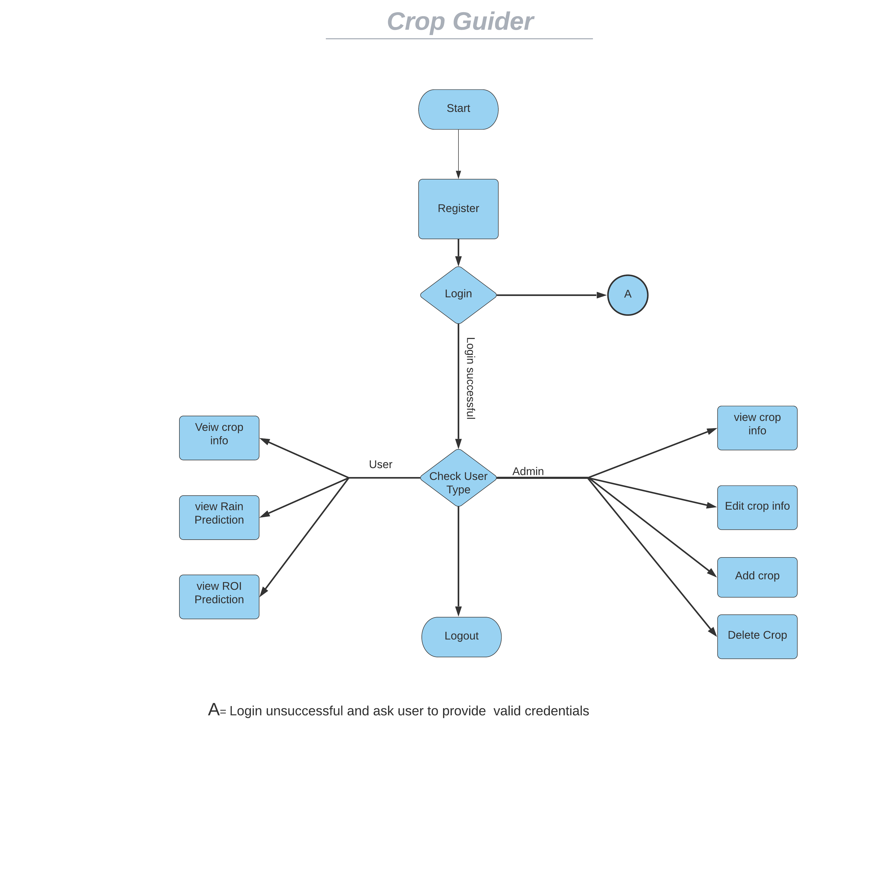

Figure : Data Flow Diagram of Crop Guider

# Detailed System Design

## Class Diagram:

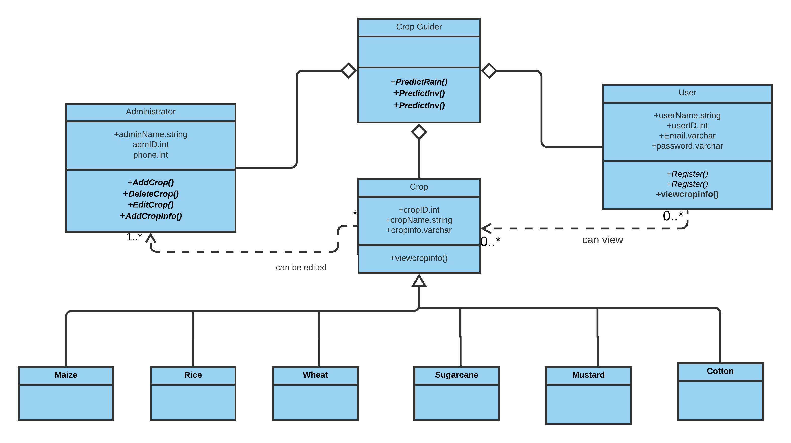

Figure : Class Diagram for Crop Guider

The main system is crop guider, which is represented by Crop Guider Class which predicts rain, investment and return on investment. Then we have Administrator Class which contains attributes like name, id and phone number. The admin can add, delete, edit crops and add any crop information. Another class is User which has the attributes like name, id, email and password. The user can register, login and view crop information. Then there is a class named Class which has the attributes like id, name and info. User class can only view information while Administrator class can edit the crop as well. There are six subclass of class Crop which include Maize, Rice, Wheat, Sugarcane, Mustard and Cotton. All the attributes of parent class i.e. Crop class are inherited in these classes.

## Sequence diagram for registration:

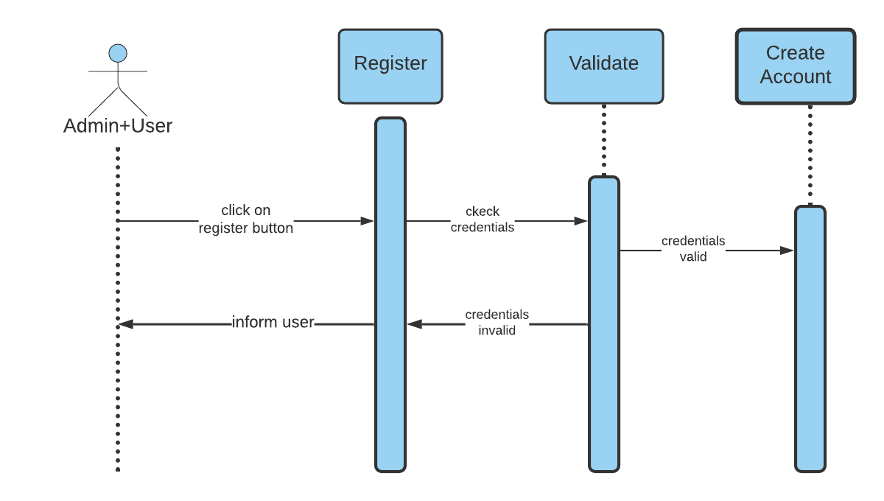

Figure : sequence diagram for registration

The admin or user clicks the website link and the system asks for registration credentials input and checks their validation if the input is wrong, the system asks the user for valid inputs and if the input is correct then the registration info is saved on the database and registered admin or user can perform their related functions.

## Sequence Diagram of Administrator

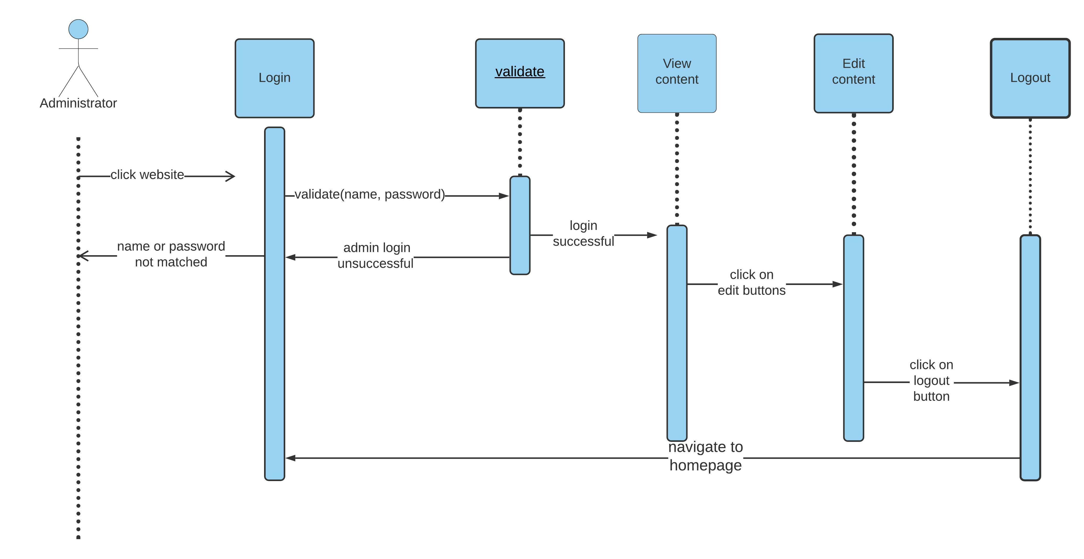

Figure : class diagram of admin

The admin clicks the website link and the system asks for credentials input and checks their validation if the input is wrong ,the system asks admin for valid inputs and if the input is correct the admin can view and edit any info in website ,and then later on he can logout of the system

## Class diagram for User

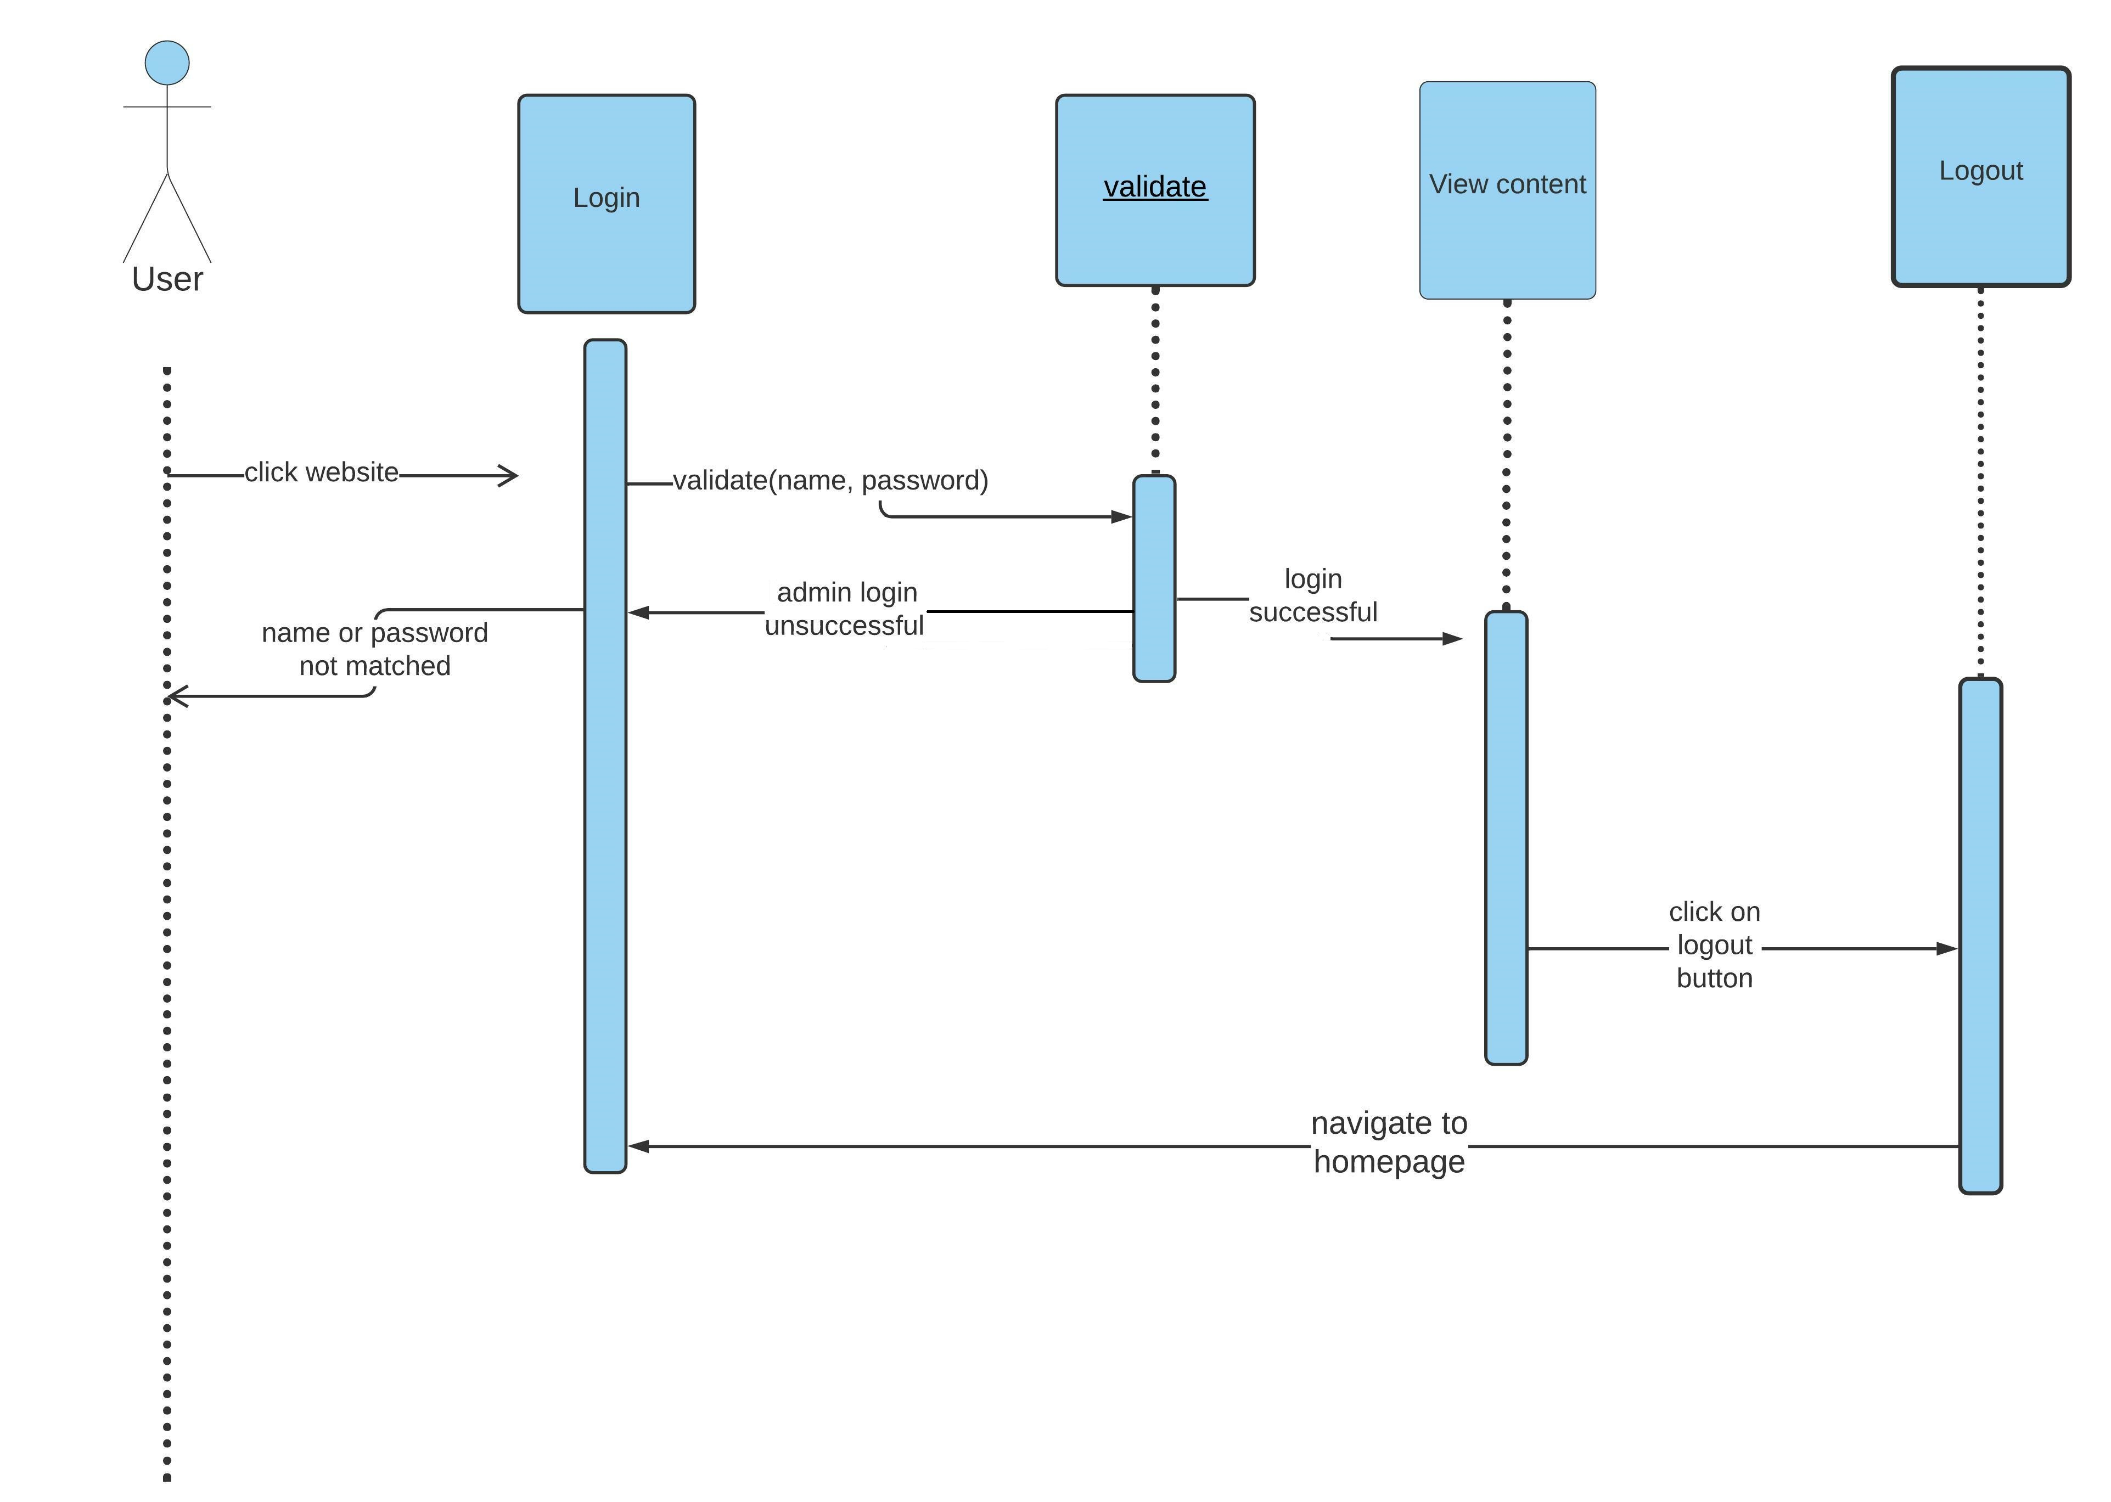

Figure : Class diagram for User

* The user clicks the website link and the system asks for credentials input and checks their validation if the input is wrong, the system asks the user for valid inputs and if the input is correct the user can only view any info on the website, he can view predictions on rain, investment and return of investment, and then, later on, he can log out of the system
* State Transaction Diagram
* Logical data model (E/R model)
* Physical data models

# Detailed GUIs

# Use Cases

* 1. Use Case Diagrams

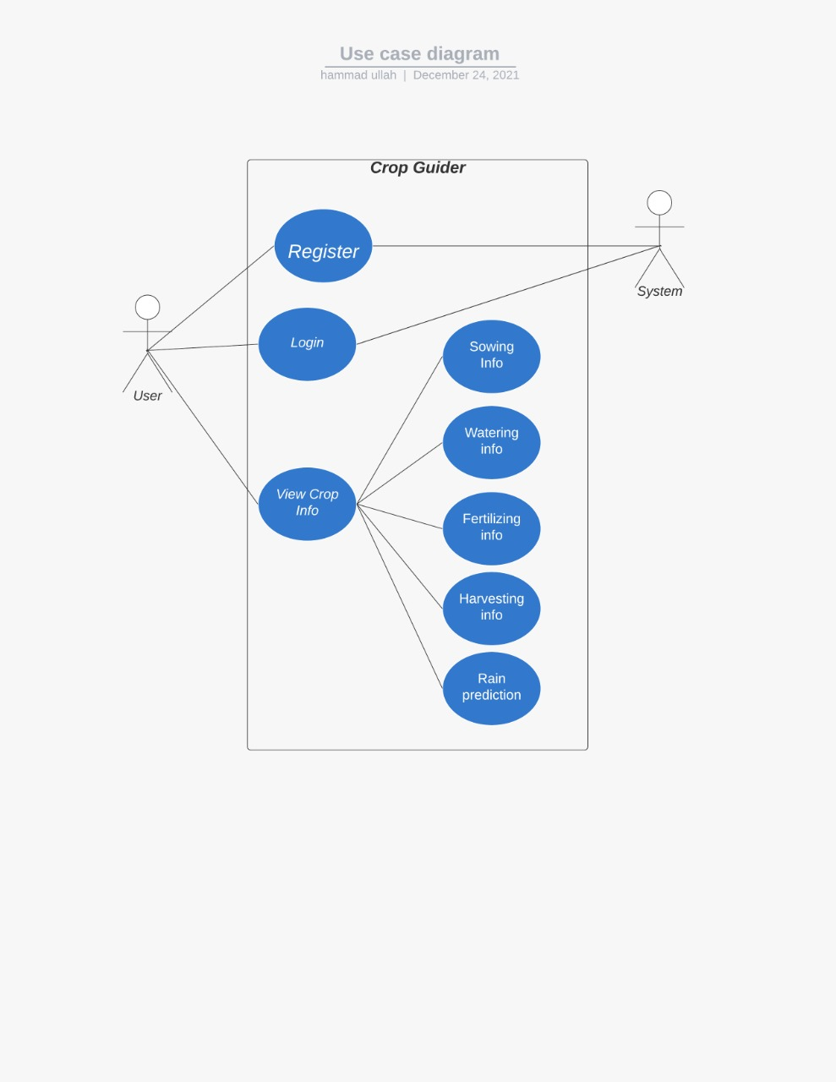

Figure Use case diagram for user

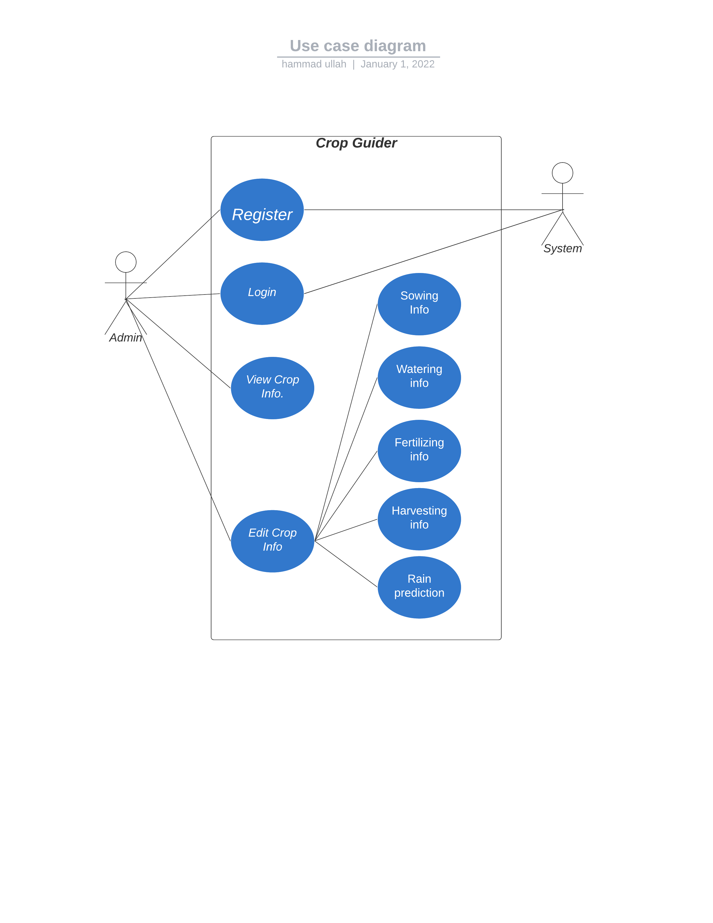

Figure : Use case diagram for Admin

* 1. Use Case Description

|  |  |  |  |  |
| --- | --- | --- | --- | --- |
| **1: Register** | | | | |
| **Actors:**  *User, Admin* | | | | |
| **Feature:** | | | | |
| **Use case Id:** | | *1* | | |
| **Pre-condition:** | | *User must have an email address to register.* | | |
| **Scenarios** | | | | |
| **Step#** | **Action** | | | **Software Reaction** |
| **1.** | *Give name, id and password* | | | *Takes input* |
| **2.** | User clicks register button | | | *Software checks the validity of credentials* |
|  |  | | |  |
| **Alternate Scenarios:** | | | | |
| **2a:**  If information is valid, the account is successfully created.  **2b:**  If information is invalid user is asked to provide valid credentials. | | | | |
| **Post Conditions** | | | | |
| **Step#** | **Description** | | | |
|  | *If registered person is admin, he/she can view and update or edit the information.* | | | |
|  | *If registered person is user, he/she can only view the information.* | | | |
| **Use Case Cross referenced** | | | *Login* | |
| **User Interface reference** | | |  | |
| **Concurrency and Response** | | | | |

|  |  |  |  |  |
| --- | --- | --- | --- | --- |
| **2: Login** | | | | |
| **Actors:**  *User, Admin* | | | | |
| **Feature:** register | | | | |
| **Use case Id:** | | *2* | | |
| **Pre-condition:** | | *User must have registered.* | | |
| **Scenarios** | | | | |
| **Step#** | **Action** | | | **Software Reaction** |
| **1.** | *Give name, id and password* | | | *Takes input* |
| **2.** | User clicks login button | | | *Software checks the validity of credentials* |
|  |  | | |  |
| **Alternate Scenarios:** | | | | |
| **2a:**  If information is valid, login is successful.  **2b:**  If information is invalid user is asked to provide valid credentials. | | | | |
| **Post Conditions** | | | | |
| **Step#** | **Description** | | | |
|  | *If registered person is admin, he/she can view and update or edit the information.* | | | |
|  | *If registered person is user, he/she can only view the information.* | | | |
|  |  | | | |
| **Use Case Cross referenced** | | | *Register* | |
| **User Interface reference** | | |  | |
| **Concurrency and Response** | | | | |

|  |  |  |  |  |
| --- | --- | --- | --- | --- |
| **3: View information** | | | | |
| **Actors:**  *User, Admin* | | | | |
| **Feature:** Login | | | | |
| **Use case Id:** | | *3* | | |
| **Pre-condition:** | | *User must login to view the information* | | |
| **Scenarios** | | | | |
| **Step#** | **Action** | | | **Software Reaction** |
| **1.** | *User clicks on desired info tab* | | | *Software provides that desired information* |
| **2.** | *User can click on edit profile tab* | | | *Software saves the changed credentials.* |
|  |  | | |  |
| **Alternate Scenarios:** | | | | |
| **2a:**  If information is valid, login information update is successful.  **2b:**  If information is invalid user is asked to provide valid credentials. | | | | |
| **Post Conditions** | | | | |
| **Step#** | **Description** | | | |
| **Use Case Cross referenced** | | | *Register, login* | |
| **User Interface reference** | | |  | |
| * **Concurrency and Response** | | | | |

|  |  |  |  |  |
| --- | --- | --- | --- | --- |
| **4: Edit information** | | | | |
| **Actors:**  *Admin* | | | | |
| **Feature:** Login | | | | |
| **Use case Id:** | | *4* | | |
| **Pre-condition:** | | *Admin must login to edit the information* | | |
| **Scenarios** | | | | |
| **Step#** | **Action** | | | **Software Reaction** |
| **1.** | *User edits information* | | | *Software saves the changed information* |
|  |  | | |  |
| **Alternate Scenarios:** | | | | |
| *None* | | | | |
| **Post Conditions** | | | | |
| **Step#** | **Description** | | | |
|  | *User will only be able to see the updated information* | | | |
|  |  | | | |
|  |  | | | |
| **Use Case Cross referenced** | | | *Register, login* | |
| **User Interface reference** | | |  | |
| **Concurrency and Response** | | | | |

|  |  |  |  |  |
| --- | --- | --- | --- | --- |
| **5: Prediction** | | | | |
| **Actors:**  *System, User* | | | | |
| **Feature:** *Login* | | | | |
| **Use case Id:** | | *5* | | |
| **Pre-condition:** | | *User must login to see the predictions* | | |
| **Scenarios** | | | | |
| **Step#** | **Action** | | | **Software Reaction** |
| **1.** | *User navigates through system* | | | *Software provides runtime predictions* |
| **Alternate Scenarios:** | | | | |
| None | | | | |
| **Post Conditions** | | | | |
| **Step#** | **Description** | | | |
|  |  | | | |
| **Use Case Cross referenced** | | | *Register, login* | |
| **User Interface reference** | | |  | |
| **Concurrency and Response** | | | | |

# Graphical User Interfaces

Give a detailed account of user interfaces included in this project.

|  |  |  |
| --- | --- | --- |
| **1: Homepage** | | |
| **Interface Id.** | | *1* |
| **Use case Reference** | | *3* |
| **Snapshot** | | |
|  | | |
| **Data dictionary reference** | | |
| **Label** | **Data dictionary identifier** | |
| 1 | *Profile* | |
|  | Tabs for crop options | |
|  | Language selector | |
|  | Motto | |
| 5 | Contact us | |
| 6 | Link to YouTube | |

|  |  |  |
| --- | --- | --- |
| **2: Specific Crop info** | | |
| **Interface Id.** | | *2* |
| **Use case Reference** | | *3* |
| **Snapshot** | | |
|  | | |
| **Data dictionary reference** | | |
| **Label** | **Data dictionary identifier** | |
| 1 | *Go to homepage* | |
|  | Question user wants to know about. | |
|  | Answer to user selected question. | |

# Requirements Traceability Matrix

|  |  |  |  |  |  |  |
| --- | --- | --- | --- | --- | --- | --- |
| **Sr. #** | **Feature** | **Use case ID** | **UI ID** | **Priority** | **Build Number** | **Use Case Cross reference**  **(Related Use Cases)** |
| 1 | View Crop | 1 | 2 | 1 | 1 | 3 |
| 2 | Edit Information | 4 |  | 2 | 2 | 3 |
|  |  |  |  |  |  |  |
|  |  |  |  |  |  |  |

*The columns carry the following meaning:*

* *Feature: Lists system features based on which use cases are built.*
* *Use Case ID: Write the ID of the use case for easy lookup*
* *UI ID: Write the user interface ID for this use case.*
* *Priority: Give an appropriate rating to each use case according to its priority*
* *Build Number: Write the reference number to which this feature belongs.*
* *Use Case Cross Ref: Write the related use cases separated with commas.*

# Risk Analysis

**(Consult your Project Manager for this section)**

*Perform an analysis of the constraints and identify the potential problems that may arise in the project due to the constraints. For this section cover the following:*

* *Risk Identification*
* *Risk Drivers*
* *Percentage Impact of Risk Drivers*
* *Risk Mitigation Plan*

# Cost Estimation Sheet

**(Consult** **your Project Manager for this section)**

|  |  |  |
| --- | --- | --- |
|  | **Software development cost** | 60$ |
|  | **Packaged software** | 10$ |
|  | **Hardware** | 20$ |
|  | **Network** | 30$ |
|  | **Client** | 5$ |
|  | **Misc.** | 10$ |
|  |  |  |
|  |  | **Total cost =125$** |

# References

*This section should provide a complete list of all documents referenced at specific point in time. Each document should be identified by title, report number (if applicable), date, and publishing organization. Specify the sources from which the references can be obtained (This section is like the bibliography in a published book).*

|  |  |  |  |
| --- | --- | --- | --- |
| **Ref. No.** | **Document Title** | **Date of Release/ Publication** | **Document Source** |
| 1 | Crop Guider.docx | 08/11/2021 | [Crop Guider.docx](https://docs.google.com/document/d/1qYhLZue92dEysYLcYpHyB_vh_-gx5awV/edit?usp=sharing&ouid=107956528172163828993&rtpof=true&sd=true) |
| 2 | Software requirement Specification.docx | 08/11/2021 | [Software Requirements Specifications.docx](https://docs.google.com/document/d/1qp6Eu2IbHPkPl3u7ZD2YgzRZp4TnhKZH/edit?usp=sharing&ouid=107956528172163828993&rtpof=true&sd=true) |
| 3 | Functional specification document | 02/01/2022 |  |

# Appendices

*Include supporting details that would be too distracting to include in the main body of the document.*